**Netflix Movies and TV Shows Analysis using SQL**



* **Project overview:**

This project involves a comprehensive analysis of Netflix's movies and TV shows data using SQL. The goal is to extract valuable insights and answer various business questions based on the dataset. The aim is to derive actionable insights and provide answers to key business questions to support decision-making in content strategy and user engagement.This provides a detailed account of the project's objectives, business problems, solutions, findings, and conclusions.

* **Objectives**:
* Analyze the distribution of content types (movies vs TV shows).
* Identify the most common ratings for movies and TV shows.
* List and analyze content based on release years, countries, and durations.
* Explore and categorize content based on specific criteria and keywords.
* **Dataset:**

The dataset used in this project is a publicly available collection of Netflix's movies and TV shows, on platforms like Kaggle. It contains comprehensive details about the titles available on Netflix as of the time the data was collected.

* ****Dataset Link:**** [Movies Dataset](https://www.kaggle.com/datasets/shivamb/netflix-shows?resource=download)
* **Schema:**

To perform structured queries and analysis using SQL, the Netflix dataset was first imported and converted into a relational table.

## **Business Problems and Solutions:**

### **Count the Number of Movies vs TV Shows:**

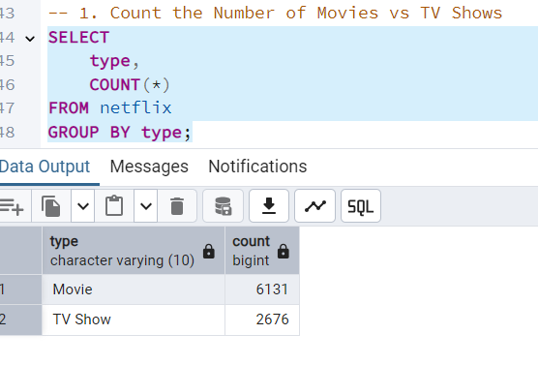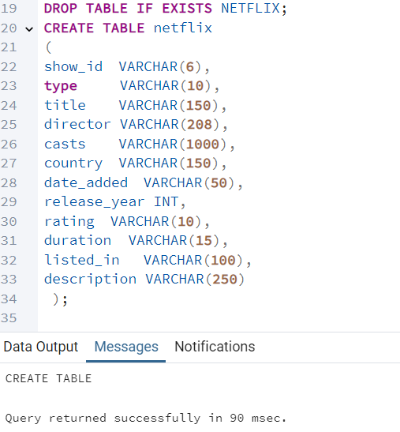

### **Find the Most Common Rating for Movies and TV Shows**

### ss4**List All Movies Released in a Specific Year (e.g., 2020)**

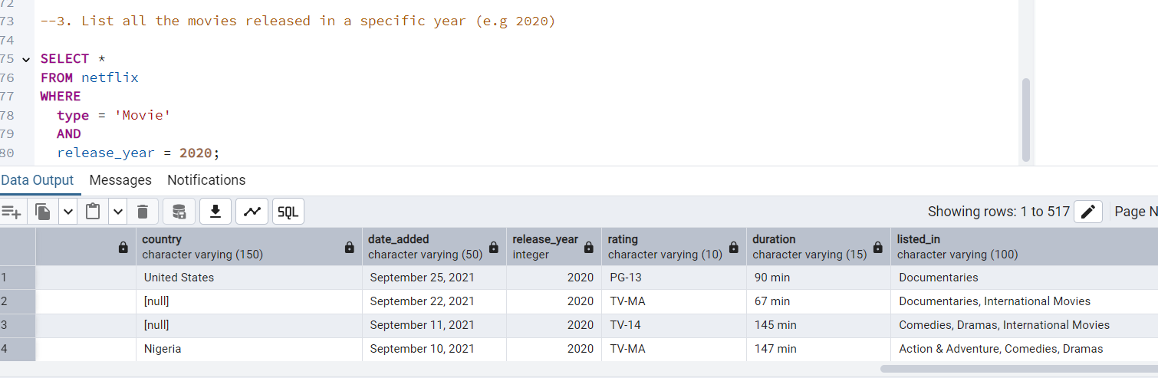

### **Find the Top 5 Countries with the Most Content on Netflix**

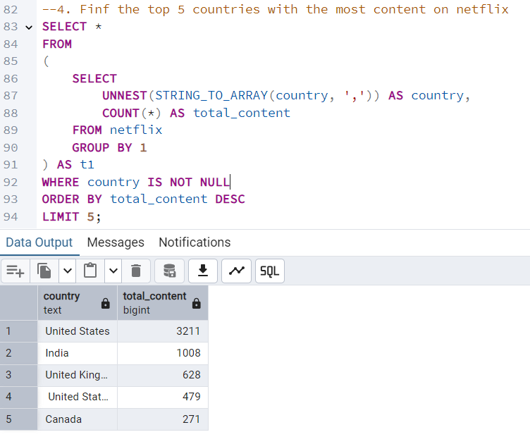

### **Identify the Longest Movie**

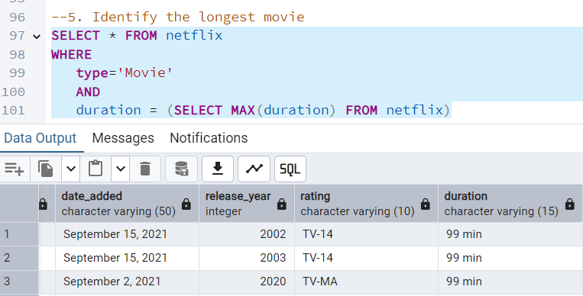

### **Find Content Added in the Last 5 Years**

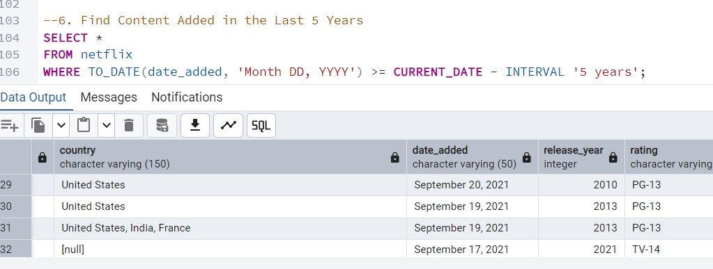

### **Find All Movies/TV Shows by Director 'Rajiv Chilaka'**

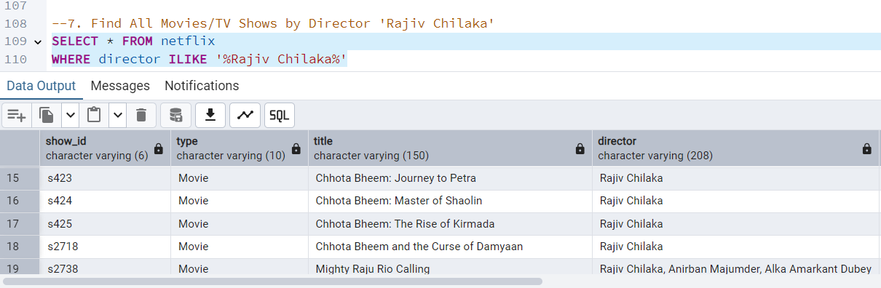

### **List All TV Shows with More Than 5 Seasons**

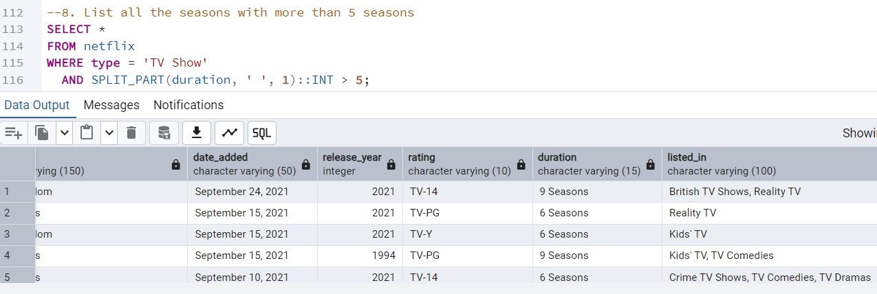

### **Count the Number of Content Items in Each Genre**

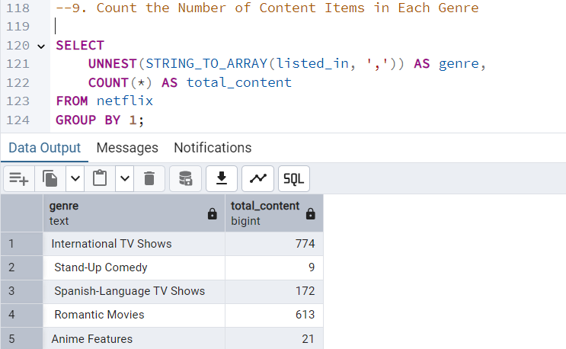

### **Find each year and the average numbers of content release in India on netflix.**

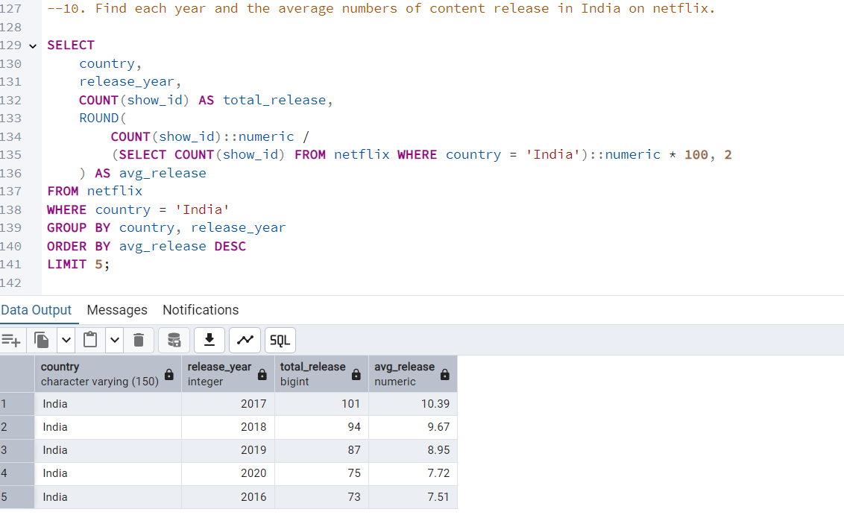

### **ss16Find the Top 10 Actors Who Have Appeared in the Highest Number of Movies Produced India**

### **Categorize Content Based on the Presence of 'Kill' and 'Violence' Keywords**

